USER’S MANUAL

TABLE OF CONTENTS:

CHAPTER I

* Purpose of Website
* Website details
* How to use
* Features
* Home
* Products
* About
* Contacts
* Account
* Product Details
* Cart
* Brands
* Footer
* Check out form

CHAPTER II

* Database
* HTML, CSS, JAVASCRIPT codes
* PHP codes

CHAPTER I

**PURPOSE OF WEBSITE**

The purpose of this website is to facilitate the transaction online especially for people in remote areas who want to shop and get to know the store. We also aim to better identify and attract buyers.

**WEBSITE DETAILS**

Selloum atbp. Store, aims to provide you with a convenient way. We offer a variety of plants from sunlight-loving to shade-loving plants, trailing, shrubs, and trees. We have Philodendrons, Ferns, Aglaonemas, Syngonium, Rubber trees, Caladiums, Peace lilies, and so much more. These will surely give a dramatic accent to your home or office.

**HOW TO USE**

These are the steps to use the website:

STEP1 -

Go to browser and search for Selloum atbp. Store.

STEP2 -

Click the store and browse.

STEP3 -

Go to “Product” to see products also the details of all the products.

STEP4 –

Click add to cart button to register or to create a lifetime shopping account of the website. Fill up the form and start checking out the products.

**FEATURES**

* HOME PAGE

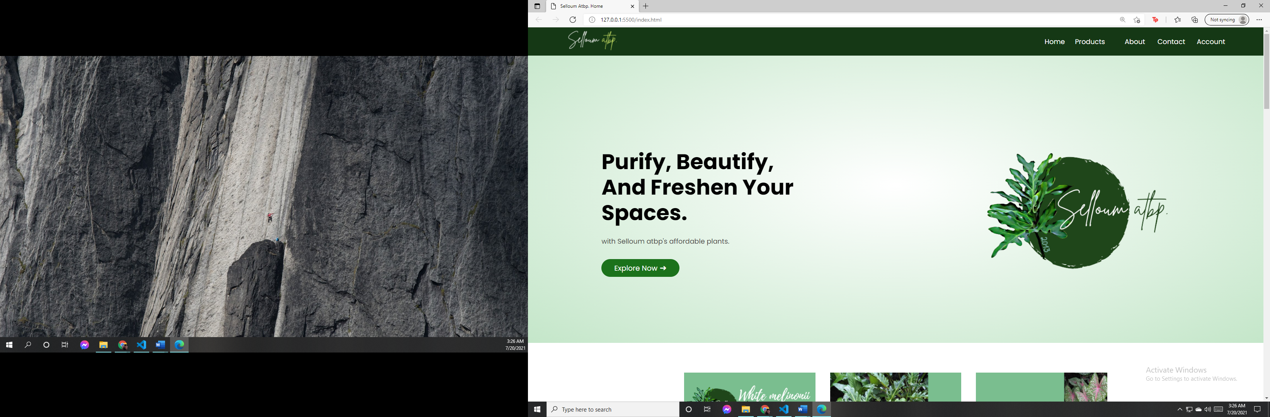

* PRODUCT PAGE

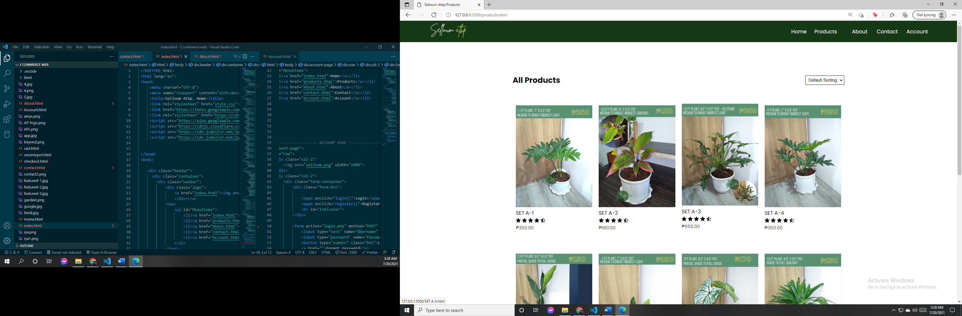

* ABOUT

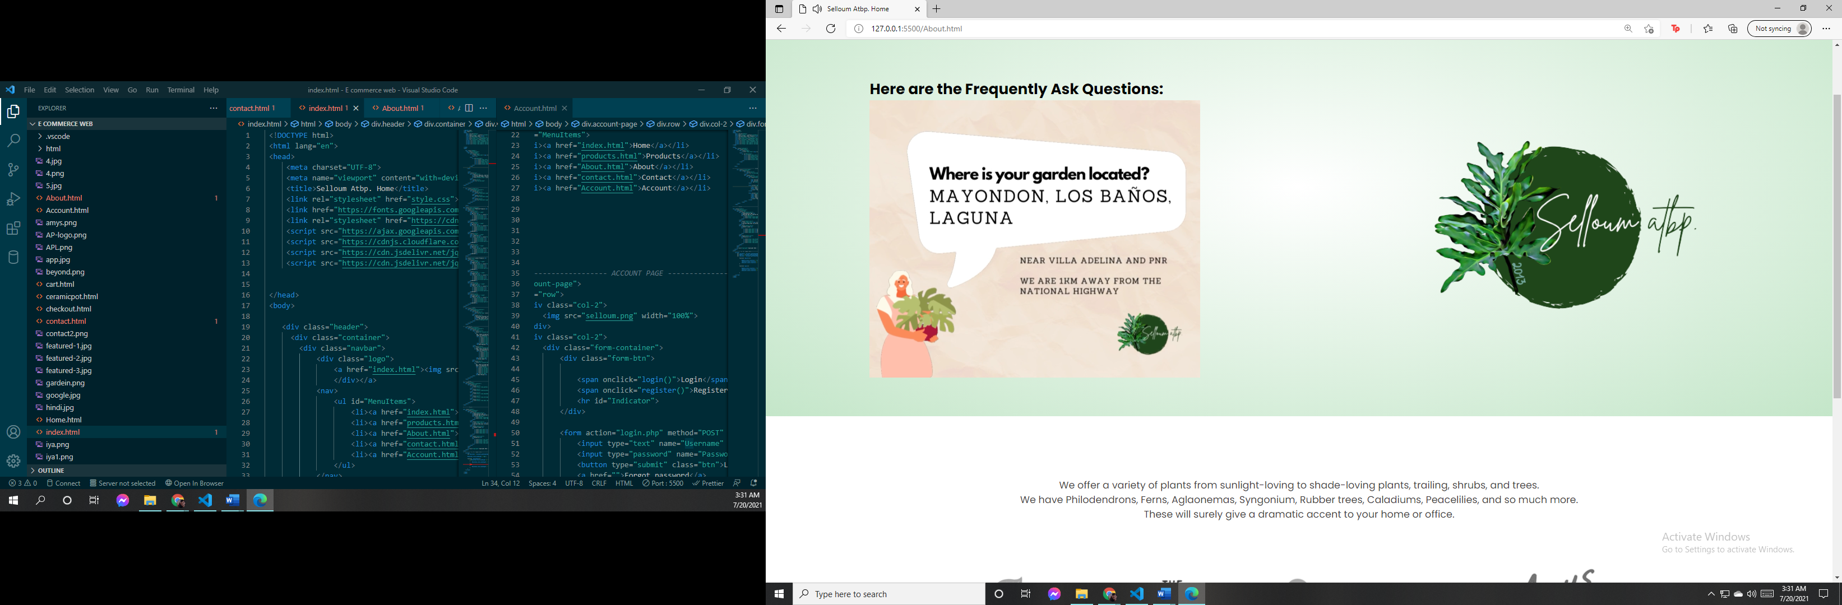

* CONTACTS

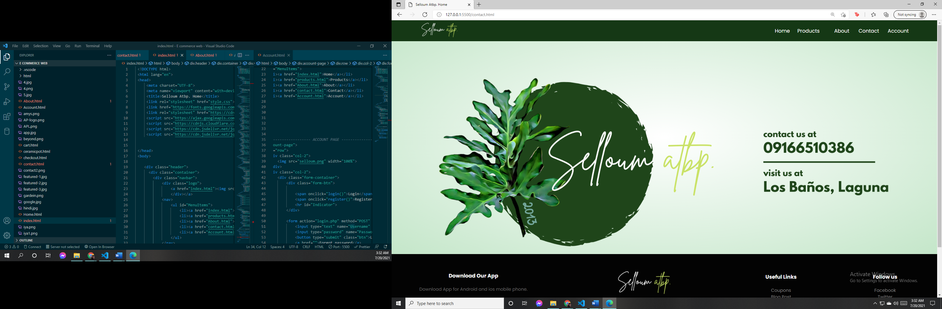

* ACCOUNT

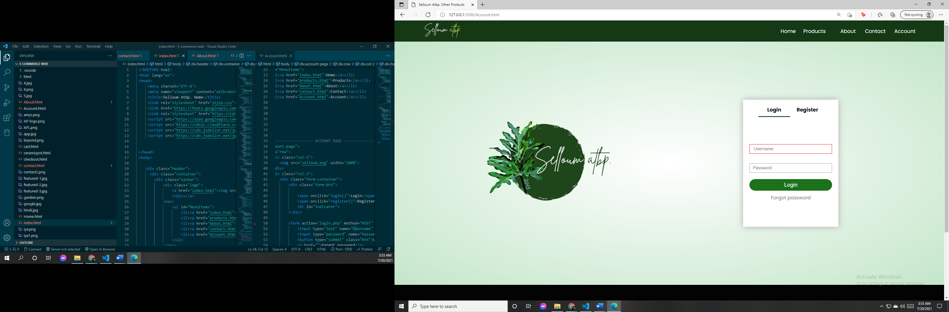

* SAMPLE PRODUCT DETAILS

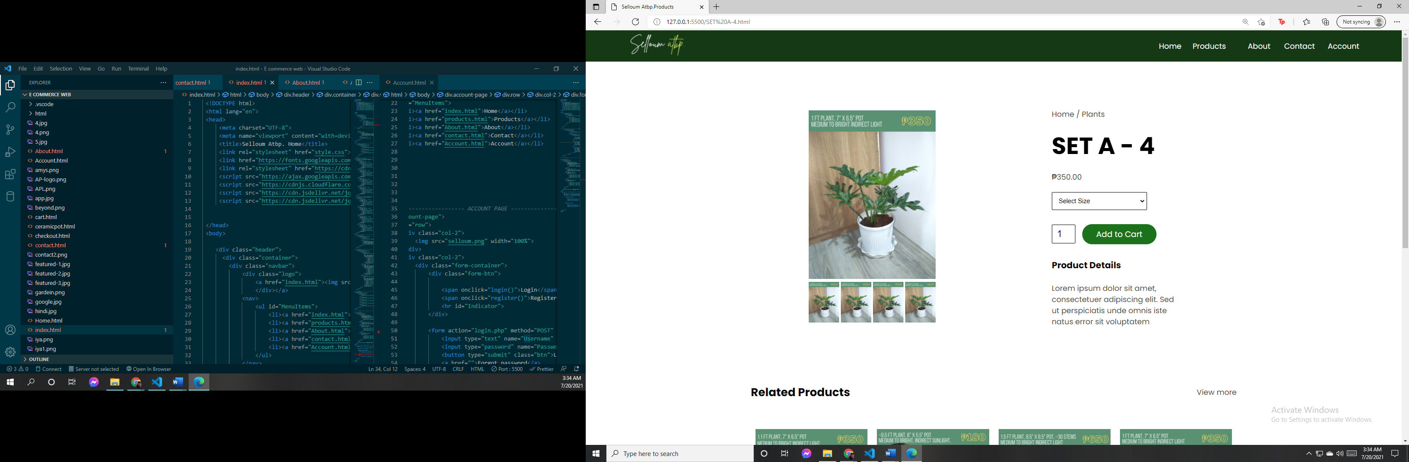

* CART PAGE

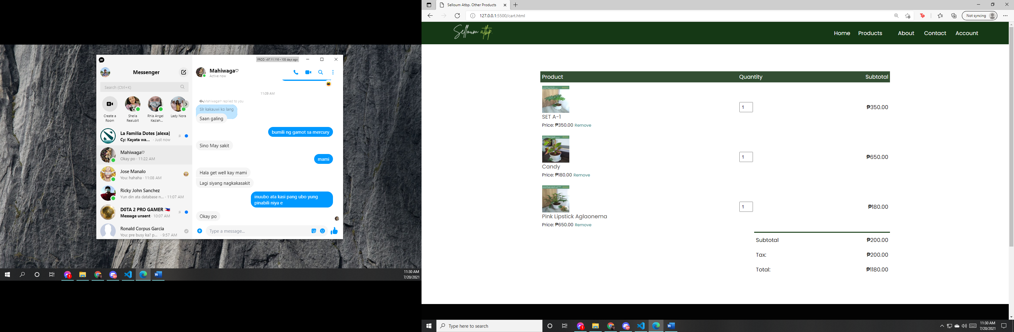

* BRANDS

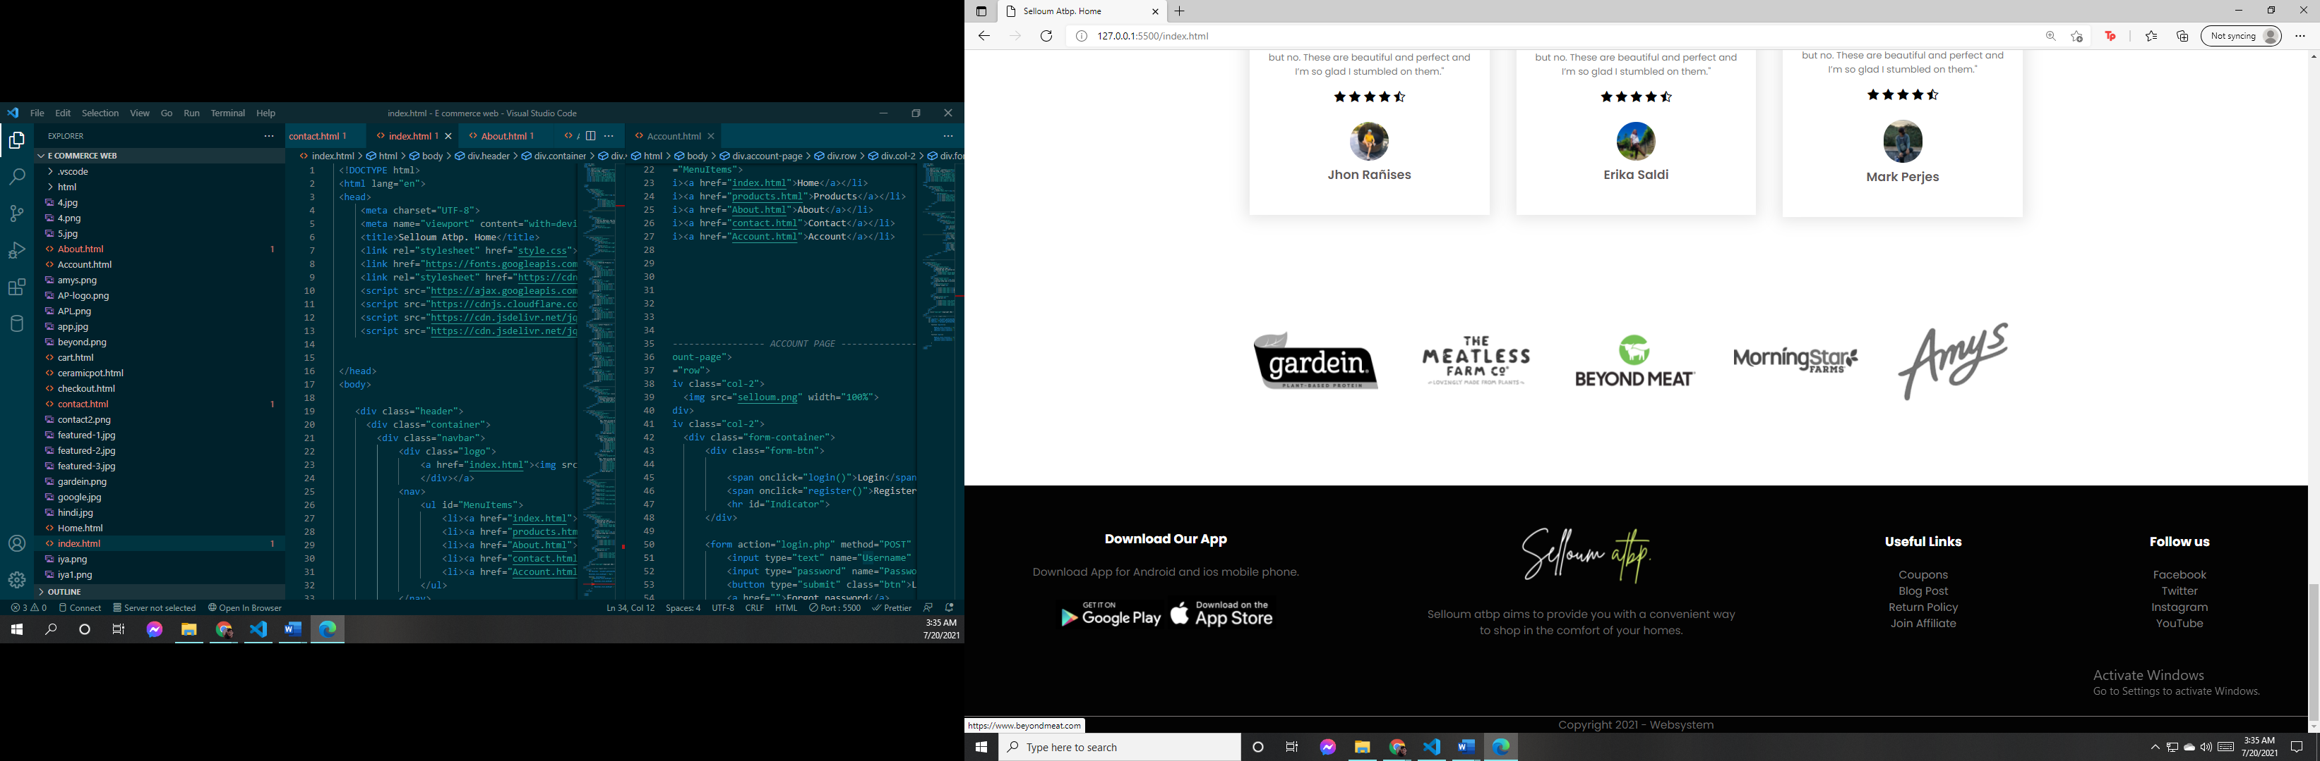

* FOOTER



* CHECKOUT FORM

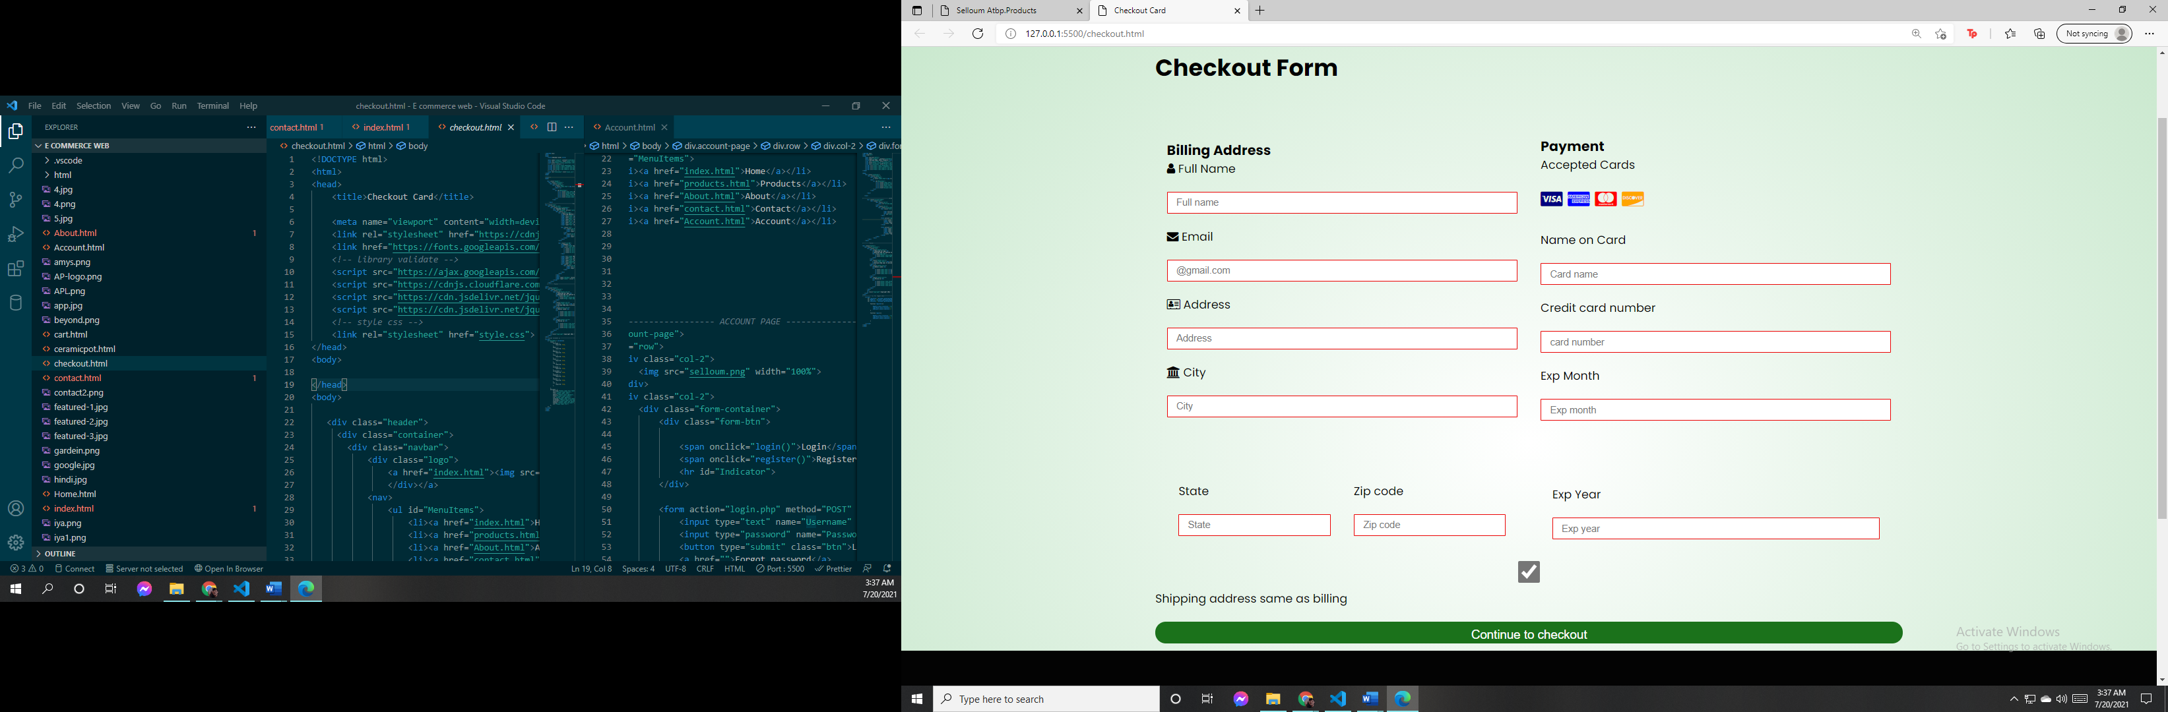

This is some of the visible and content of Selloum atbp's ecommerce website. If you want to know more or if you want to go shopping, just go to such website link.

CHAPTER II

The content of this chapter is what is contained in the website or some of the source code of how the website was made.

**DATABASE**

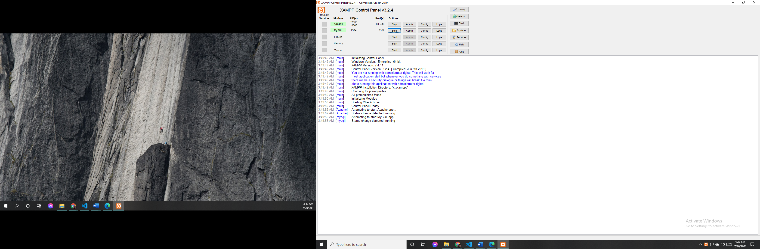

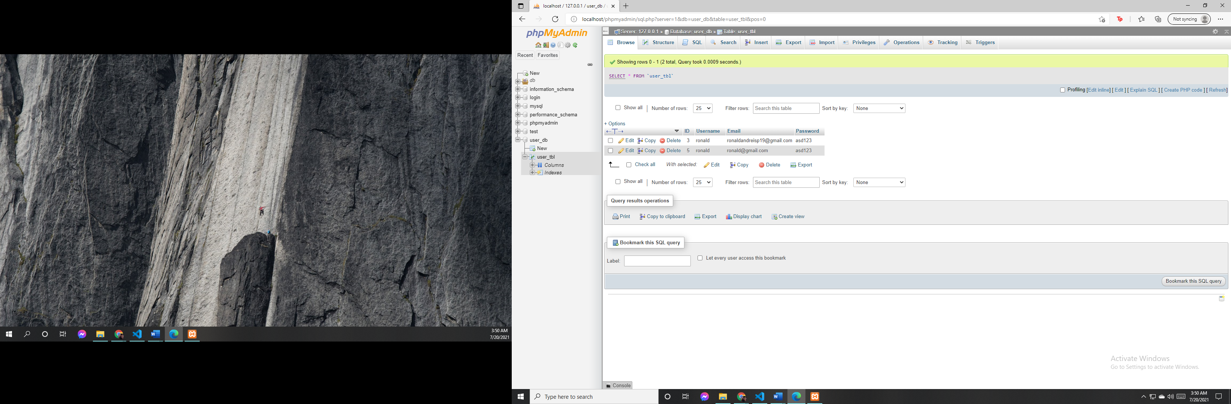

* The group used XAMPP and PHP local host to enable the system and have the DATABASE.

**HTML, CSS, JAVASCRIPT CODES**

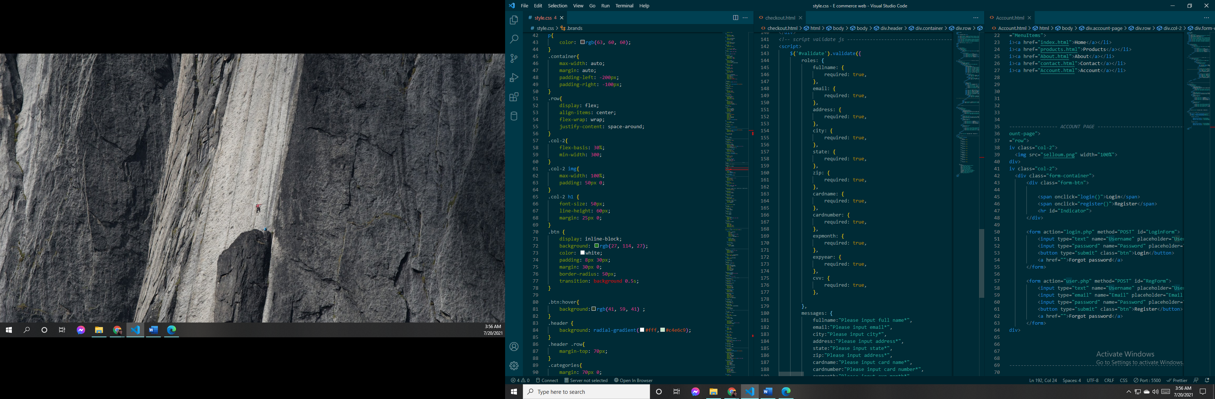

* They also used CSS, HTML and JAVASCRIPT for the website design and to enable it.

**PHP CODES**

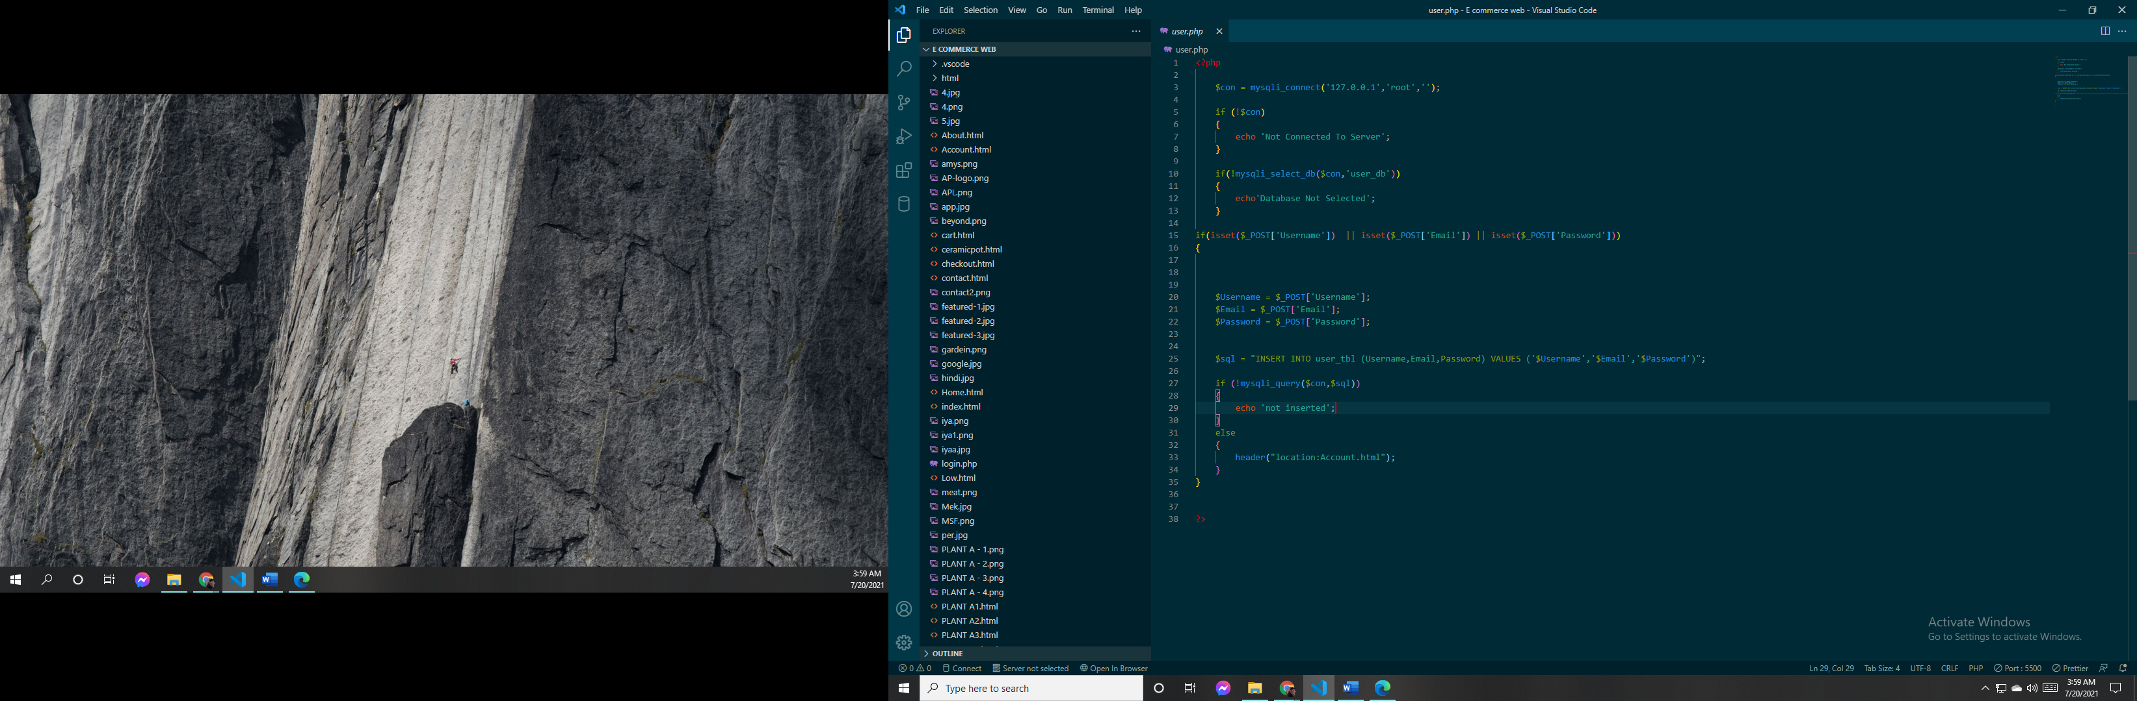

* These are our PHP codes connected to our DATABASE to enter the details stored here.